Final Project

Probability

**Exercise 1**

1. About 1/125 of births are non-identical twins and 1/300 of births are identical twins. Elvis had a twin brother who died in childbirth. What is the probability that Elvis was the identical twin? (It can be assumed that the probability of having a son and a daughter is equal to 1/2).
2. There are two bowls of cookies. Bowl 1 has 10 almond cookies and 30 chocolate chip cookies. In bowl 2 there is 20 almond cookies and 20 chocolate chip cookies. Eric chose a bowl at random and chose a cookie from it at random. The cookie selected is chocolate. What is the probability that Eric chose Bowl 1?

*Answer*:

1. Information:

* About 1/125 of births are non-identical twins $⟹p_{non-identical twins}=\frac{1}{125}$
* About 1/300 of births are identical twins. $⟹p_{identical twins}=\frac{1}{300}$
* The probability of having a son or a daughter is equal to 1/2 $⟹p_{son\&daughter }=\frac{1}{2}$
* The probability of birth of twins= $p_{ twins}=\frac{1}{125}+\frac{1}{300}=\frac{17}{1500}$

By this information, the probability that Elvis had an identical twin brother is:

$$p_{Elvis had twin}=\frac{p_{dentical twins}}{p_{ twins}} =\frac{\frac{1}{300 }}{\frac{17}{1500}}$$

$$p_{Elvis had twin}=\frac{5}{17}$$

1. Information:

* Eric got chocolate cookie.
* There are two bowls:
$$p_{choose a bowl}=\frac{1}{2}$$

* Bowl 1 : 40 cookies. 10 almond cookies, 30 chocolate cookies:

$p_{choclate (1)}=\frac{30}{40}=\frac{3}{4}$

* Bowl 2 : 40 cookies . 20 almond cookie, 20 chocolate cookies:

${ p}_{choclate(2)}=\frac{20}{40}=\frac{1}{2}$

From that:

* The probability of choosing chocolate cookie from bowl 1:
$$p_{choclate bowl 1}=p_{choose a bowl}×p_{chocolae (1)}=\frac{1}{2}×\frac{3}{4}=\frac{3}{8}$$

* The probability of choosing chocolate cookie from bowl 2:
$$p_{choclate bowl 2}=p_{choose a bowl}×p_{chocolae(2)}=\frac{1}{2}×\frac{1}{2}=\frac{1}{4}$$

* The probability of choosing chocolate cookie:

$$p_{choclate 2 bowls}=p_{choclate bowl 1}×p_{choclate bowl 2}=\frac{3}{8}+\frac{1}{4}=\frac{5}{8}$$

By this information, the probability that Eric will choose the first bowl:

$$p_{choose bowl 1}=\frac{p_{choclate bowl 1}}{p_{choclate 2 bowls}}=\frac{\frac{3}{8}}{\frac{5}{8}}$$

$$p_{choose bowl 1}=\frac{3}{5}$$

**Exercise 2:**

In 1995, M&M company added the color blue. Before this year, the color distribution

The M&M bag looks like this:

30% Brown, 20% Yellow, 20% Red, 10% Green, 10% Orange, 10% Tan.

As of 1995, the distribution looks like this:

24% Blue, 20% Green, 16% Orange, 14% Yellow, 13% Red, 13% Brown.

Your friend has 2 M&M bags, one from 1994 and one from 1996 and he is not willing to reveal it to you which bag belongs to which year. But he gives you one candy from each bag. One candy is yellow and one is green. What is the chance that the yellow candy came from the 1994 bag?

*Answer*:

We need that the yellow candy came from the package before 1995 ( i.e 1994), and the green from the package after 1995 (i.e 1996).

Information:

* There is two option of date:
$$p_{choose year}=\frac{1}{2}$$

* In 1994 the colors distribution was:

30% Brown, 20% Yellow, 20% Red, 10% Green, 10% Orange, 10% Tan.

The probability to choose a yellow candy from 1994:

$${ p}_{yellow 1994}=\frac{20}{100}×\frac{1}{2}=\frac{1}{10}$$

The probability to choose a green candy from 1994:

$${ p}_{green 1994}=\frac{10}{100}×\frac{1}{2}=\frac{1}{20}$$

* In 1996 the colors distribution was:

24% Blue , 20% Green, 16% Orange, 14% Yellow, 13% Red, 13% Brown.

The probability to choose a yellow candy from 1996:

$${ p}_{yellow 1996}=\frac{14}{100}×\frac{1}{2}=\frac{7}{100}$$

The probability to choose a green candy from 1996:

$${ p}_{green 1996}=\frac{20}{100}×\frac{1}{2}=\frac{1}{10}$$

From that:

* The probability to choose a yellow candy
$${ p}_{yellow }={ p}_{yellow 1994}+{ p}_{yellow 1996}=\frac{1}{10}+\frac{7}{100}=\frac{17}{100}$$

* The probability to choose a green candy

$${ p}_{green }={ p}_{green 1994}+{ p}_{green 1996}=\frac{1}{20}+\frac{1}{10}=\frac{3}{20}$$

By this information, the probability to choose yellow candy from 1996 and green candy from 1996:

$$p_{yellow 1994 green 1996}=\frac{{ p}_{yellow 1994}}{{ p}_{yellow }}×\frac{{ p}_{greem 1994}}{{ p}_{green }}=\frac{1}{\frac{10}{\frac{17}{100}}} ×\frac{1}{\frac{10}{\frac{3}{20}}}$$

$$p_{yellow 1994 green 1996}=\frac{20}{51}$$

**Exercise 3:**

You went to the doctor following an ingrown toenail. The doctor randomly selected you to perform a blood test for swine flu. It is statistically known that this flu affects 1 in 10,000 people in the population. The test 99 percent accurate in the sense that the probability of a false positive is 1%. This means that the test mistakenly classified a healthy person as a sick person is 1 percent. The probability of false negative is 0 - no chance that the test will tell a person with swine flu that he is healthy. In the test you came out positive (you have the flu).

1. What is the probability that you have swine flu?
2. Suppose you have recently returned from Thailand and you know that 1 in 200 people who have recently returned from Thailand have returned with swine flu. Given the same situation as in question A, what is the (corrected) probability that you have swine flu?

*Answer***:**

1. Information:

* The probability of having a flue:
$$p_{seak}\frac{1}{10000}$$

* The probability of not having a flue:
$$p_{health}=1-p_{have flue}=1-\frac{1}{10000}=\frac{9999}{10000}$$

* Return true when healthy: $1\%=\frac{1}{100}$
* Return false when sick =0
* Return true when sick =100%
* The probability of having a flue and the test return true:
$$p_{true positive}=\frac{1}{10000}×1=\frac{1}{10000}$$

* The probability of not having a flue and the test return true:
$$p_{false positive}=p_{health}×False positive\frac{9999}{10000}×\frac{1}{100}=9.999$$

* The probability that the test returns true:

$$p_{true }=p_{true positive}+p_{false positive}=\frac{1}{10000}+9.99999=0.010099$$

By this information, the probability of having a flue when the test returns true:

$$p_{having flue}= \frac{p_{seak}}{p_{true }}=\frac{\frac{1}{10000}}{0.010099}$$

$$p_{having flue}=0.0099$$

1. Information:

* The probability of having flue -Thailand:

$p_{flue after Tailand=}\frac{1}{200}$

* The probability of not having a flue after Thailand:
$$p_{health}=1-p_{flue after Tailand}=1-\frac{1}{200}=\frac{199}{200}$$

* The probability of having a flue and the test return true:
$$p_{true positive}=\frac{1}{200}×1=\frac{1}{200}$$

* The probability of not having a flue and the test return true:
$$p_{false positive}=p_{health}×False positive\frac{199}{200}×\frac{1}{100}=\frac{199}{20000}$$

* The probability that the test returns true:

$$p_{true }=p_{true positive}+p_{false positive}=\frac{1}{200}+\frac{199}{20000}=\frac{299}{20000}$$

By this information, the probability of having a flue after Thailand when the test returns true:

$$p_{having flue}= \frac{p_{seak}}{p_{true }}=\frac{\frac{1}{200}}{\frac{299}{20000}}=\frac{100}{299}$$

$$p_{having flue}=0.33444$$

Random Variables:

**Exercise 1:**

Roi is playing a dice game with Yael.  
 Roi will roll 2 six-sided dice, and if the sum of the dice is divisible by 3, he will win 6$. If the sum is not divisible by 3, he will lose 3$.  
What is Roi’s expected value of playing this game?

*Answer*:

We will look at the sum of the numbers and check which are divided by 3 and which are not.

|  |  |  |  |  |  |  |
| --- | --- | --- | --- | --- | --- | --- |
| 6 | 5 | 4 | 3 | 2 | 1 | + |
| 7 | 6 | 5 | 4 | 3 | 2 | 1 |
| 8 | 7 | 6 | 5 | 4 | 3 | 2 |
| 9 | 8 | 7 | 6 | 5 | 4 | 3 |
| 10 | 9 | 8 | 7 | 6 | 5 | 4 |
| 11 | 10 | 9 | 8 | 7 | 6 | 5 |
| 12 | 11 | 10 | 9 | 8 | 7 | 6 |

The numbers: 3,6,9,12 is divided by 3. The probability of getting them:

$$p_{get3}=\frac{2}{36}$$

$$p_{get6}=\frac{5}{36}$$

$$p_{get9}=\frac{4}{36}$$

$$p_{get12}=\frac{1}{36}$$

* The probability of getting number that divided by 3:
$$p_{divided by 3}=\frac{2}{36}+\frac{5}{36}+\frac{4}{36}+\frac{1}{36}=\frac{1}{3}$$

* The probability of getting number that not divided by 3:

$p_{ not divided by 3}=1-p_{divided by 3}=\frac{2}{3}$

By this information about $\frac{1}{3}$ of the games Roi will win, which means that he will gain 6$ for win, and about $\frac{2}{3}$ of the games Roi will lose, which means that he will lose 6$ for two lost.

from that, Roi will not gain or lose any value because it will even out.

**Exercise 2:**

Sharon has challenged Alex to a round of Marker Mixup. Marker Mixup is a game where there is a bag of 5 red markers numbered 1 through 5, and another bag with 5 green Markers numbered 6 through 10. Alex will grab 1 marker from each bag, and if the 2 markers add up to more than 12, he will win 5 $, If the sum is exactly 12, he will break even, and If the sum is less than 12, he will lose $ 6.

What is Alex's expected value of playing Marker Mixup?

*Answer*:

|  |  |  |  |  |  |
| --- | --- | --- | --- | --- | --- |
| 5 | 4 | 3 | 2 | 1 | + |
| 11 | 10 | 9 | 8 | 7 | 6 |
| 12 | 11 | 10 | 9 | 8 | 7 |
| 13 | 12 | 11 | 10 | 9 | 8 |
| 14 | 13 | 12 | 11 | 10 | 9 |
| 15 | 14 | 13 | 12 | 11 | 10 |

* The probability of getting number above 12: $\frac{6}{25}$
* The probability of getting number below 12: $\frac{15}{25}=\frac{3}{5}$
* The probability of getting number equal to 12: $\frac{4}{25}$

From that information we see that for every 25 games:

about 6 of the games, he will gain 5$ (=30$ total).

about 15 of the games, he will lose 6$ (=90$ total).

By that, after 25 games he will lose 60$.

**Exercise 3:**

A division of a company has 200 employees, 40%, percent of which are male. Each month,

the company randomly selects 8 of these employees to have lunch with the CEO.

What are the mean and standard deviation of the number of males selected each

month?

*Answer*:

Information:

* There is: 80 males, 120 females.

$p_{males}=\frac{80}{200}=\frac{2}{5}$

Note that 40% of the employs is males, so 40% from all the cases, man will be in the 8 people who was at lunch:

By that,

The mean is:

$$mean=8×\frac{2}{5}$$

$$mean=3.2$$

.

The std is:

There is 9 option of male been in the lunch: 0,1,2,3,4,5,6,7,8

So, by the formula:

$$σ=\sqrt{\frac{1}{n}\sum_{i=1}^{n}{{\left(x_{i}-\overline{x}\right)}^{2}}}$$

$$σ=\sqrt{\frac{1}{9}\sum_{i=0}^{8}{{\left(x_{i}-3.2\right)}^{2}}}$$

$$=\sqrt{\frac{{\left(0-3.2\right)}^{2}+{\left(1-3.2\right)}^{2}+{\left(2-3.2\right)}^{2}+{\left(3-3.2\right)}^{2}+{\left(4-3.2\right)}^{2}+{\left(5-3.2\right)}^{2}+{\left(6-3.2\right)}^{2}+{\left(7-3.2\right)}^{2}+{\left(8-3.2\right)}^{2}}{9}}$$

$$=\sqrt{\frac{65.76}{9}}$$

$$=2.7$$

The std is 2.7

**Exercise 4:**

Different dealers may sell the same car for different prices. The sale prices for a particular car are normally distributed with a mean and standard deviation of 26,000$ and 2,000$, respectively. Suppose we select one of these cars at random. Let X = the sale price (in thousands of dollars) for the selected car. Find P(26<X<30).

*Answer*:

By the normal distribution, in order to get a price between 26,000 and 30,000, we look at the 2 std’s to the right of the mean.

By that, and by the rule of “68%, 95%, 99.72%”, we need to look at 95% area, and divide it by 2, because we don’t want the price to be below the average.

So, the probability of a sale price between 26,000 and 30,000 is 47.5%.

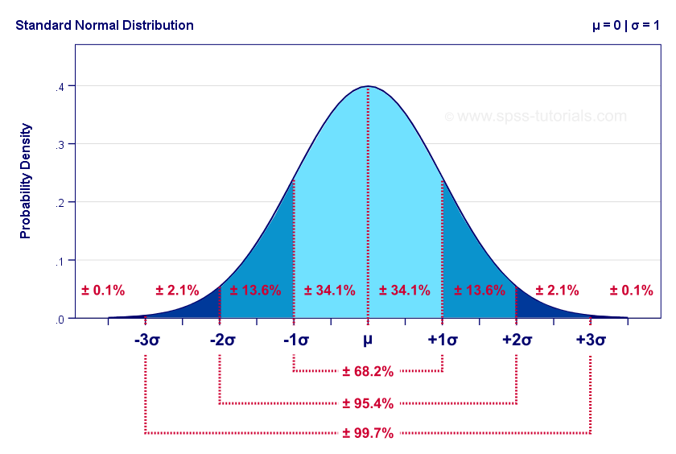

47.5%

**Exercise 5:**

Given the following distribution, what is P(x>3)?

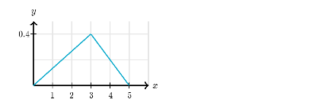

*Answer*:

In order to calculate the probability, lets note that all the area in the triangle is 100% of the total probability.

So, in order to calculate the probability to $x>3$ we use the formula of triangle area:

$$p_{x>3}=\frac{2×0.4}{2}$$

$$p_{x>3}=0.4$$

**Exercise 6:**

A company has 500 employees, and 60% of them have children. Suppose that we randomly

select 4 of these employees.

What is the probability that exactly 3 of the 4 employees selected have children?

*Answer:*

Information:

* The number of employs that have children:
$$\frac{60}{100}×500=300$$

* Note that the number of employs that don’t have children:

$$\frac{40}{100}×500=200$$

By that, the probability that exactly 3 of the 4 employees selected have children is:

(Note that the order of the selection is not important, so we multiply the answer by 4).

$$p=\frac{300}{500}×\frac{299}{499}×\frac{298}{498}×\frac{200}{497}×4$$

$$p=0.346$$

**Exercise 7:**

Look at the next Graph. What is the expected value of X?

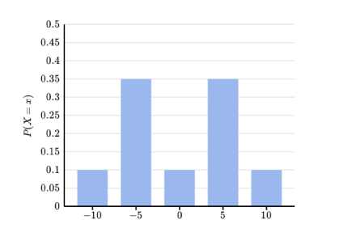

*Answer:*

We use the formula of random variable:

$$\sum_{i=0}^{n}{p(x_{i})×x_{i}}$$

By that, the calculation is:

$$answer=\left(-10×0.1\right)+\left(-5×0.35\right)+\left(0×0.1\right)+\left(5×0.35\right)+\left(10×0.1\right)$$

$$answer=0$$